E-Governance Grievance Redressal System

DOCUMENT CONTROL

Item | Details
Project Name | E-Governance Grievance Redressal System
Author | Debarghya Sikder
Date | 7th January, 2026
Status | Working

PURPOSE OF THE DOCUMENT
This document describes the system architecture, design decisions, component structure, APIs, data models, and non-functional aspects of the E-Governance Grievance Redressal System.
It is intended for:
- Developers
- Reviewers
- Interview discussions
- Maintenance & enhancement planning
SYSTEM OVERVIEW

Business Objective
Provide a scalable, secure, and maintainable E-Governance platform to:
- Enable citizens to register and track grievances digitally
- Ensure accountability by assigning grievances to relevant departments
- Monitor grievance lifecycle and resolution timelines
- Improve transparency through centralized tracking and notifications
- Support future growth using a microservices-based architecture
Business Rules

- Only authenticated users with valid roles can access system features, enforced through JWT-based role authorization.
- Citizens are the only users permitted to lodge grievances, and each grievance must be associated with exactly one category and department.
- Every grievance is assigned a unique system-generated grievance ID and timestamp at the time of submission.
- Grievances follow a strictly enforced lifecycle: Submitted → Assigned → In Review → Resolved → Closed, with no status skipping allowed.
- Grievances are automatically routed to the appropriate department based on category-to-department mapping.
- Only authorized department officers can update grievance status and submit resolution remarks.
- A grievance is eligible for escalation if it remains unresolved beyond a predefined resolution timeframe.
- Citizens may submit feedback and ratings only after a grievance has been resolved, with limited scope for reopening.
- Administrative and supervisory users have read-only access to analytics and performance reports derived from grievance data.
- All grievance actions, status changes, and resolutions are logged with timestamps to ensure transparency, traceability, and auditability.

High-Level Features
- Citizen registration and secure login using JWT authentication
- Online grievance lodging with description and document/image upload
- Centralized grievance tracking with unique reference ID
- Grievance lifecycle management: Submitted → Assigned → In Progress → Resolved → Closed
- Automatic or manual department assignment for accountability
- Role-based dashboards and access control (Citizen / Officer / Supervisor / Admin)
- Status change notifications via notification service
- Escalation of grievances if not resolved within defined time limits(SLA)
- Feedback submission by citizens after grievance resolution
- Reports and analytics for department-wise and category-wise performance(ADMIN)

FLOW:
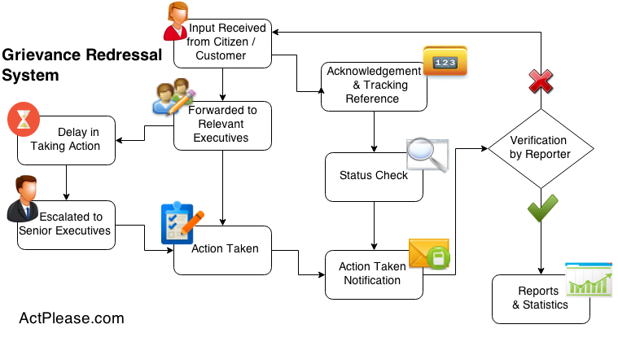

Roles & Access Control:
- Citizen – Register, submit grievances, track status, and provide feedback
- Department Officer – View and resolve assigned grievances
- Supervisory Officer – Monitor grievance status and escalations
- System Admin – Manage users, departments, roles, and grievance categories

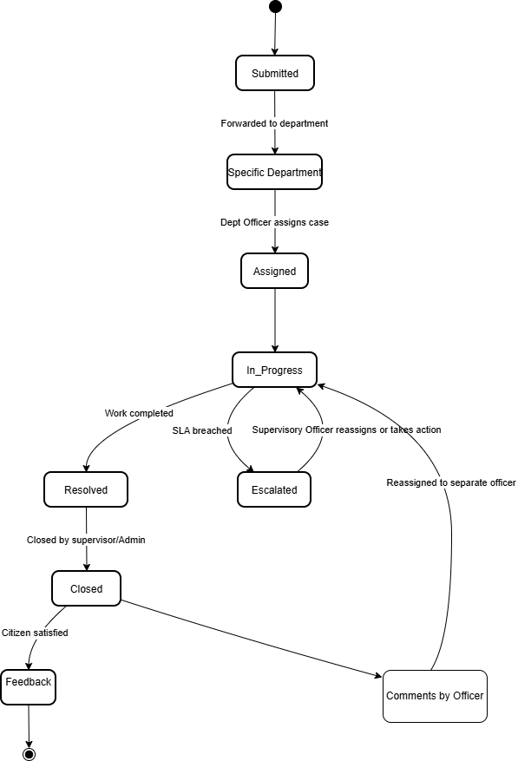

Architecture Diagram:

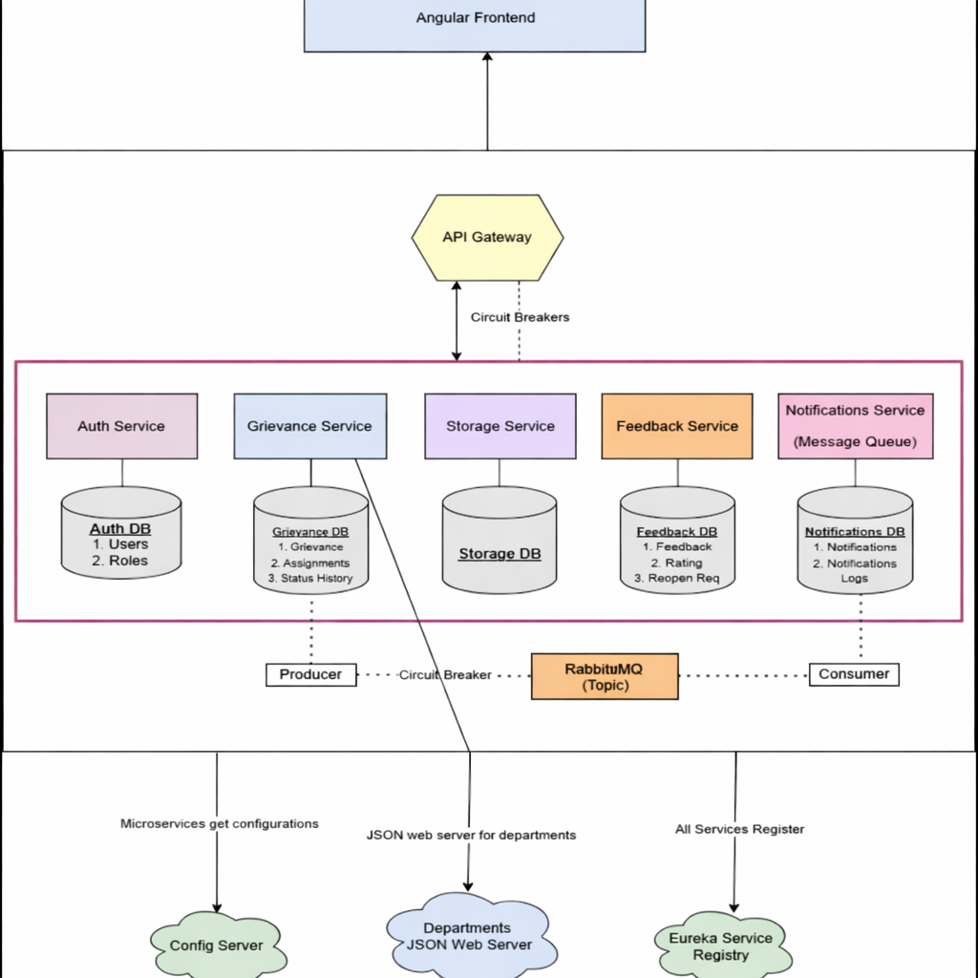

MicroServices

- API Gateway
- Security Service
- Config Server
- Grievance Service (id, grievance_number, user_id, department_id,title, description, status)
- Notification service (id, user_id, subject, message)
- Auth Service (id, name, description)
- Feedback Service (id, grievance_id, citizen_id, comment)

Auth Service

Users
Attribute | Type | Description
_id | String | User ID
name | String | Full name
email | String | Login email
role | Enum | CITIZEN / DO / SO / ADMIN
departmentId | String | Nullable (for DO / CW)
createdAt | DateTime | Created timestamp

Roles
Attribute | Type | Description
_id | String | Role ID
roleName | String | Role name
description | String | Role description

Grievance Service

grievances
Attribute | Type | Description
_id | String | Grievance ID
citizenId | String | Citizen user ID
departmentId | String | department
assignedOfficerID | Integer | Officer ID
categoryCode | String | WATER, ELECTRICITY
subCategoryCode | String | SUPPLY_DELAY, OVERFLOW
description | String | Complaint text
status | Enum | GrievanceStatus
createdAt | DateTime | Creation time
updatedAt | DateTime | Last update

assignments

Attribute | Type | Description
_id | String | Assignment ID
grievanceId | String | Grievance reference
assignedTo | String | Case Worker ID
assignedAt | DateTime | Assignment time

status history
Attribute | Type | Description
_id | String | History record ID
grievanceId | String | Grievance reference
status | Enum | Status value
updatedBy | String | User ID
remarks | String | Optional note
updatedAt | DateTime | Timestamp

Feedback service

feedback

Attribute | Type | Description
_id | String | Feedback ID
grievanceId | String | Grievance reference
citizenId | String | Citizen ID
comments | String | Feedback text
submittedAt | DateTime | Timestamp

ratings
Attribute | Type | Description
_id | String | Rating ID
grievanceId | String | Grievance reference
rating | Integer | 1–5
submittedAt | DateTime | Timestamp

Notification service Using RabbitMQ
Attribute | Type | Description
_id | String | Notification ID
userId | String | Recipient
message | String | Notification text
type | Enum | EMAIL / SMS
status | String | SUBMITTED/ASSIGNED
createdAt | DateTime | Timestamp

Endpoints

- User Service

Authentication & Security Service APIs
HTTP Method | Endpoint | Description | Access Role | Notes
POST | /auth/register | Register a new user | Citizen / Admin | Department account creation via request header
POST | /auth/login | Authenticate user and issue JWT | All Users | Returns JWT token
POST | /auth/logout | Logout user | Authenticated User | Invalidates session/token
GET | /auth/validate | Validate JWT token | Internal / Gateway | Used by API Gateway

User Service APIs
HTTP Method | Endpoint | Description | Access Role | Notes
GET | /users | Fetch all users | Admin | Supports pagination
GET | /users/{userId} | Fetch user details by ID | Admin, Supervisor | Restricted access
PUT | /users/{userId} | Update user profile | Admin, Supervisor | Profile information only

Role & Department Mapping APIs
HTTP Method | Endpoint | Description | Access Role | Notes
GET | /users/by-role/{role} | Get users by role | Admin | Example: CITIZEN, OFFICER
GET | /users/by-department/{departmentId} | Get users by department | Admin | Used for officer assignment
PUT | /users/{userId}/role | Assign or update user role | Admin | Role-based access enforced
PUT | /users/{userId}/department | Assign user to department | Admin | Mandatory for officers

- Department Service -

Method | Endpoint | Role | Description
GET | /departments | Public | Get All Departments (for Dropdowns/Filters).
POST | /departments | Admin | Create a new Department.
GET | /departments/{id} | Public | Get Single Department details.
PUT | /departments/{id} | Admin | Update Department details.
DELETE | /departments/{id} | Admin | Soft delete a department.
POST | /departments/{id}/officers | Supervisor | Assign an existing User to this Department (as Officer).
GET | /departments/{id}/officers | Supervisor | List officers specifically for this department.
GET | /departments/{id}/categories | Public | Get categories (e.g., Water -> "Pipe Leak", "Bad Quality").
POST | /departments/{id}/categories | Admin | Add a new grievance category.
GET | /departments/categories | Public | Flat list of all categories (for Search).

3. Grievance Service
Handles the lifecycle: Submitted → Assigned → In Progress → Resolved.

HTTP Method | Endpoint | Description | Access Role | Notes
POST | /grievances | Lodge a new grievance | Citizen | Generates a unique grievance ID (PNR-like)
GET | /grievances/my-grievances | List grievances of logged-in citizen | Citizen | Supports pagination
GET | /grievances | List all grievances | Admin, Supervisor | Supports filters like ?status=PENDING&deptId=2
GET | /grievances/{id} | Get full details of a grievance | Citizen, Officer, Admin, Supervisor | Access restricted to authorized users
PATCH | /grievances/{id}/assign/{officerId} | Assign grievance to an officer | Supervisor | Can be auto-assigned or manual
PATCH | /grievances/{id}/status | Update grievance status | Officer | Includes resolution remarks
POST | /grievances/{id}/comments | Add comment to grievance | Citizen, Officer | Supports clarification & discussion
GET | /grievances/{id}/comments | Fetch grievance comment history | Citizen, Officer | Used for chat-style UI

4. Feedback Service

(loop or only once - decide?)

Method | Endpoint | Role | Description
POST | /feedbacks | Citizen | Submit feedback. Check: If grievanceId already has feedback, throw Error.  Body: { "grievanceId": "123", "rating": 5, "comment": "Fast service!" }
GET | /feedbacks/grievance/{id} | Admin | Check if feedback exists for a ticket.
GET | /feedbacks/average | Admin | Get average rating per department.  (for Admin Dashboard)

5. API Gateway

- /api/auth/** → Security Service

- /api/users/** → User Service

- /api/grievances/** → Grievance Service

- /api/departments/** → Department Service

- /api/feedbacks/** → Feedback Service

6. DepartmentService

Method | Endpoint | Role | Description
GET | / | Public/Auth | Get All Departments. Used to populate the "Select Department" dropdown on the frontend or filters on dashboards.
GET | /{id} | Public/Auth | Get Single Department. Returns details like name, description, and contact info.
POST | / | ADMIN | Create Department. Add a new department to the system.
PUT | /{id} | ADMIN | Update Department. Edit name or contact email.
DELETE | /{id} | ADMIN | Delete Department. (Soft delete recommended so old grievances don't break).
GET | /{id}/categories | Public/Auth | Get Categories by Dept. If user selects "Water Dept", call this to show ["Pipe Leak", "Low Pressure"].
POST | /{id}/categories | ADMIN | Add Category. Add a new issue type to a department.
GET | /categories | Public/Auth | Get All Categories. Flat list of all possible issues (useful for search).

7.Notification Service

Method | Endpoint | Role | Description
POST | /notifications/send | Internal | Manually trigger email/SMS.
GET | /notifications/my | Any | View notification history in the app.

Notification On:

i. User submits grievance
ii.Assigned to Officer
iii. Officer changes status
iv. status of grievance changes

Backend
Java 21
Spring Boot 3.5.x
Spring Web
Spring Data MongoDB (Reactive)
Spring Validation
MongoDB (1 Database per microservice- Total 4 databases)
Spring Security with JWT
Maven
Frontend
● Angular 21
● TypeScript
● Angular Material
● Reactive Forms

